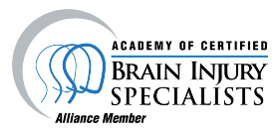
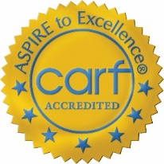
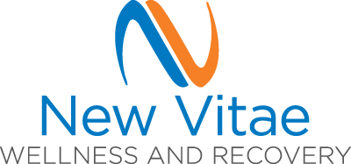

Action Recovery
Residential Habilitation Services Neurocognitive Structured Day Habilitation Services
2022 Demographics and Outcomes
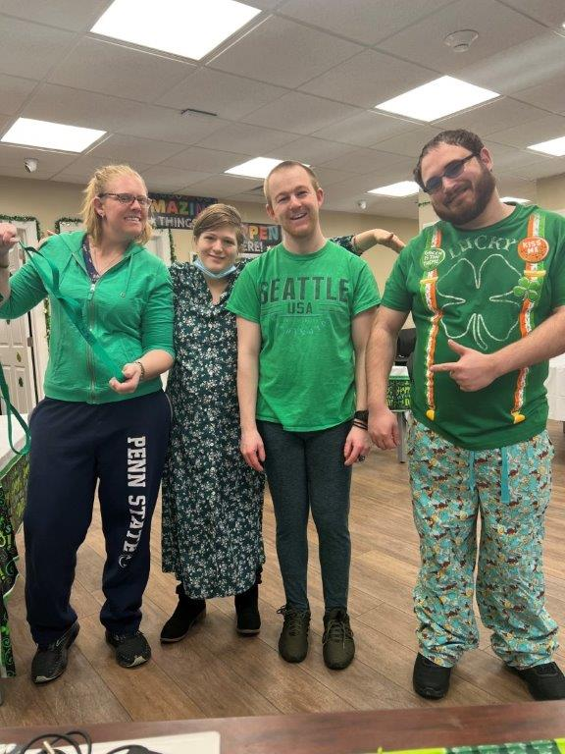
Who We Are
The mission of New Vitae Wellness and Recovery’s Action Recovery Services is to promote hope, health and wellness for individuals affected by brain injury and other neurological impairment. We accomplish this through a supportive, multi-disciplinary team that work together to provide integrated rehabilitation services, with specialization and experience in assisting those who require supports related to behavioral health challenges and/or addiction, and who have had difficulty finding stable living arrangements and services through other providers. Services ensure a unified model focusing on physical and behavioral health. Coordination of specialists, including a licensed nutritionist, occupational/speech/ physical therapists, and medical physicians offer options to promote holistic health.
Who We Serve…by the numbers.
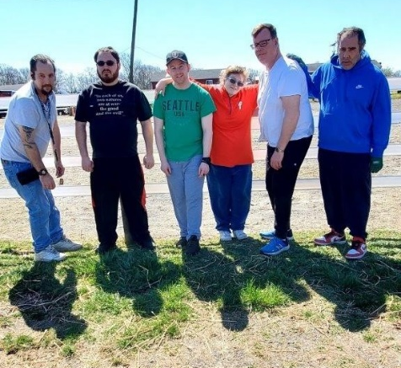
New Vitae Action Recovery served a total of 36 individuals during 2022 with two 8-person residences and four apartments available for individuals seeking residential supports. All 36 individuals also took advantage of services through the Neurocognitive Structured Day Habilitation Services.
Average length of stay: 33 months
72% male/28% female
58% are below age 45, with 14% age 60+
83% Caucasian/17% African American/0% Hispanic
72% Graduated high school or obtained a GED
100% have a co-occurring behavioral health diagnosis, and 31% have a co-occurring substance related diagnosis. Of individuals Action Recovery served in 2022 53% have more than one behavioral health diagnosis:
25% have a diagnosis of Bipolar Disorder
33% have a diagnosis of Major Depressive Disorder
14% have a diagnosis of Schizoaffective Disorder
19% have a diagnosis of Schizophrenia
22% have a diagnosis of a Mood Disorder
22% have a diagnosis of Anxiety, Panic or Phobia
This shows an increase in individuals with a co-occurring behavioral health diagnosis served in the Action Recovery program. This increase relates to the increase in behavioral health managed care organizations referring individuals with co-occurring brain injuries, with the expectation (realized for some) of transitioning funding to a physical disabilities/brain injury waiver funding through Medicaid. Ready access to New Vitae’s array of behavioral health service allows ready access to competent and experienced behavioral health professionals and treatments.
Statistics have been fairly consistent in that Action Recovery works with a large population of individuals who sustained their brain injury from some type of a motor vehicle accident. Medical issues come in as the second highest contributor to brain injury; however, this is at a much lower rate.
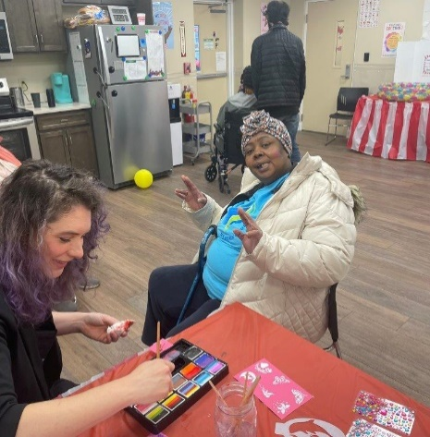
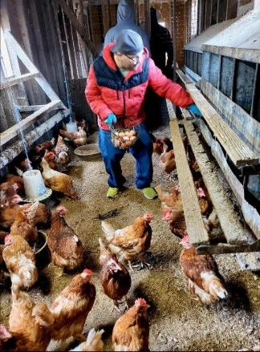
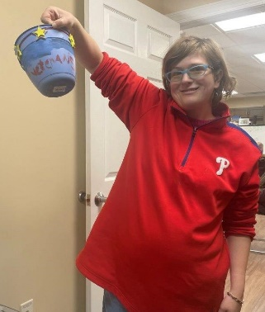
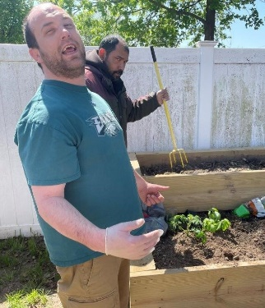
Creative expression, gross motor development/coordination activities, and providing experiences of competency are just some ways to contribute to growth, while mitigating potential for deteriorating function.

Payor Types:
Payor types in 2022 show the majority of individuals utilize Medicaid waiver funds for payment of services, followed by Medicaid Non-Waiver Funding. Action Recovery also accepts payment via Worker’s Compensation, Department of Veterans Affairs Community Care Network, single-case agreements with other insurers, and private payment arrangements.

Outcomes
Functional Improvements: To monitor and assure quality of care, Action Recovery measures and tracks functional levels for each program member using the Mayo-Portland Adaptability Inventory (MPAI-4), an evidence-based assessment tool commonly used in the field of brain injury as an evaluation of rehabilitation programs. The MAPI-4 measures the level of functional impairment in three major categories: Ability, Adjustment, and Participation for individuals with a diagnosis of brain injury:
Ability Index measures sensory, motor, and cognitive abilities
Adjustment Index measures mood, interpersonal interactions, family interactions
Participation Index measures social contacts, initiation, money management, life skills
Positive Score Stability is demonstrated by changes of less than +/- 2 points over a three-year period. T-Scores between 40 and 60 would be considered average of individuals involved in outpatient, community-based or residential rehabilitation program following a brain injury.
The table to the left shows scores from the 1st quarter of 2020 compared to the 4th quarter of 2022. Showing a significant improvement in Participation Score and Score Stability with a slight improvement in Abilities and Adjustment scores, as well as the overall Score totals.

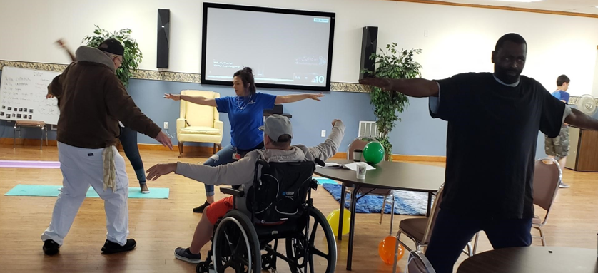

Hospitalization Rates:
Individuals with brain injury often see significant co-occurring medical and psychiatric issues as a direct result of their injury as well as due to complications related to diminished level of function (example: falls, skin breakdown and respiratory issues related to decreased mobility, injuries sustained secondary to impulsivity or other behaviors, etc.). Rates of hospitalization are tracked by Action Recovery to ensure we are providing the support needed to maintain health and wellness.

Community Integration:
The CIQ is divided into three sub scores, corresponding to integration in the home, social integration, and productivity. Higher scores indicate higher levels of community integration. Responses usually indicate that the individual performs the activity alone, with another person, or that the activity is typically performed by someone else.
Data indicates an increase in Social and Home integration overall, while a decrease in scores for Productivity Integration. While COVID-19 restrictions had prevented significant participation with others, the lifting of some restrictions as well as the programs effort to decrease isolation and provide safe means to be with others, is reflected in the increased Social Integration score.
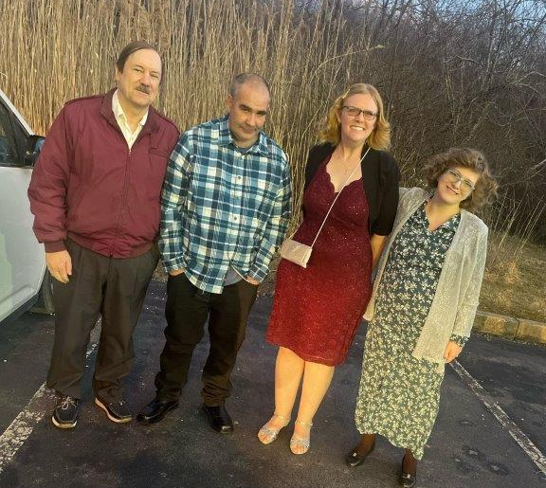
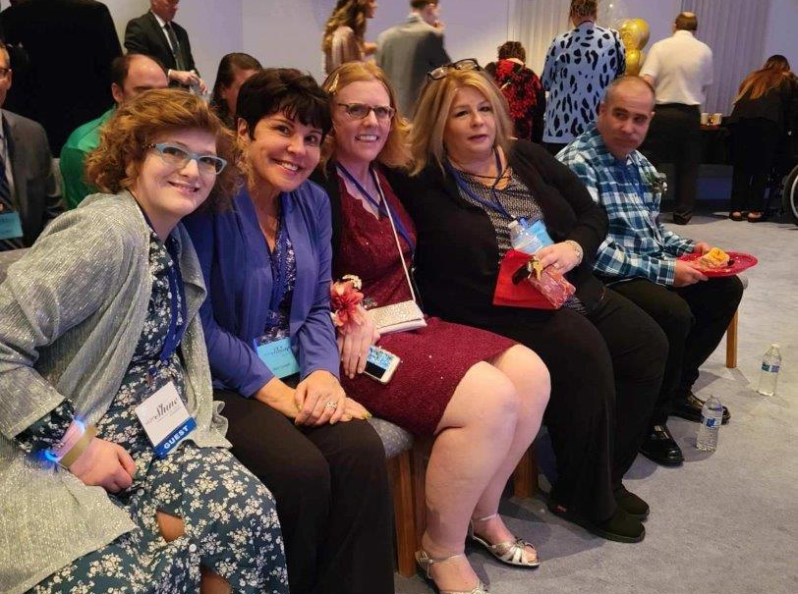

Program Member/Family/Other Stakeholder Satisfaction: To further assess the quality of our services, each year, we ask program members to provide us with feedback regarding services.
88%
My service plan goals reflect my needs, goals, and hopes.

91%
I am likely to recommend
Action Recovery
for brain injury services.
84%

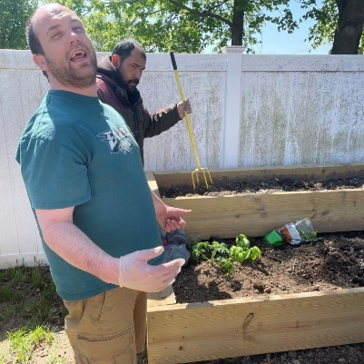
of participants feel positively about their involvement in social and community activities while involved with Action Recovery.

97%
93%
I am satisfied with the services my family member receives.

of participants feel positively about the quality of staff.
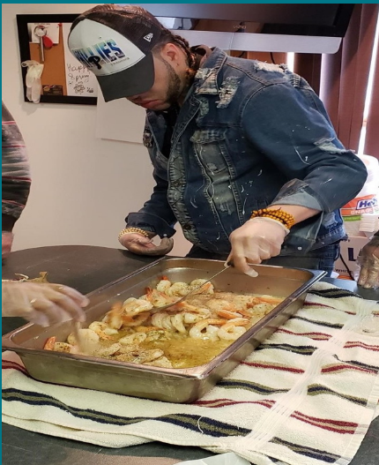
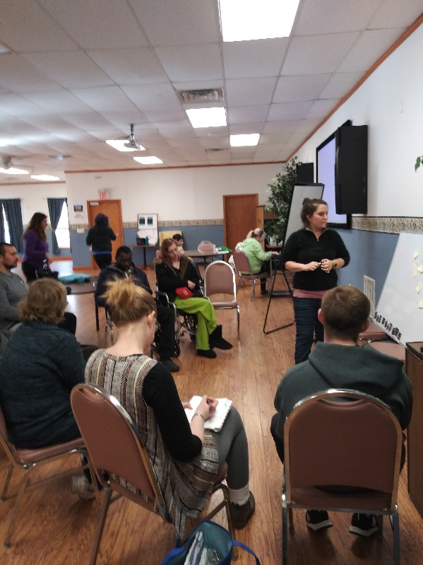
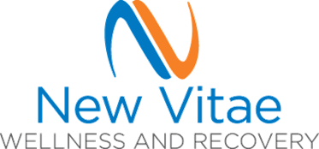
“You have created a home and community for my son. We are all grateful.”

“Your staff is top notch! The regular team meetings help us keep on top of what is going on with [our daughter], and she is finally back to more community activity. Thank you!”
.”

Action Recovery
5201 St. Joseph’s Road
Limeport, PA 18060
610.928.0173

